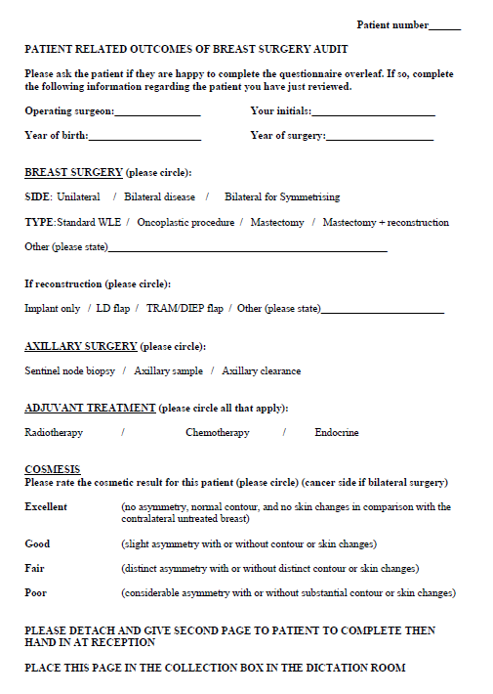
Supplementary 1: Clinician Sheet incorporating Harris Harvard Cosmesis Scale

